CS 305 Project One Template

Document Revision History

Version | Date | Author | Comments
1.0 | 09/15/2026 | Yara

Client



Instructions
Submit this completed vulnerability assessment report. Replace the bracketed text with the relevant information. In this report, identify your security vulnerability findings and recommend the next steps to remedy the issues you have found.

- Respond to the five steps outlined below and include your findings.
- Respond using your own words. You may also include images or supporting materials. If you include them, make certain to insert them in the relevant locations in the document.
- Refer to the Project One Guidelines and Rubric for more detailed instructions about each section of the template.

Developer
Yara Padilla

1. Interpreting Client Needs
Determine your client’s needs and potential threats and attacks associated with the company’s application and software security requirements. Consider the following questions regarding how companies protect against external threats based on the scenario information:

- What is the value of secure communications to the company?
- Are there any international transactions that the company produces?
- Are there governmental restrictions on secure communications to consider?
- What external threats might be present now and in the immediate future?
- What modernization requirements must be considered, such as the role of open-source libraries and evolving web application technologies?

Artemis Financial Company prioritizes application security to protect the sensitive information clients entrust to it. It offers a diverse range of financial services, including financial planning, retirement planning, investment management, and savings management. These services require collecting and storing personal and financial data, making secure communication fundamental to the organization's operations. Robust encryption protocols protect information from unauthorized access while ensuring confidentiality, integrity, and authentication (NIST, n.d.). Maintaining these security measures is essential to uphold client trust and confidence.
Artemis Financial engages with clients internationally, which demands international data transfers as part of its standard business operations. This practice mandates the company implement additional security measures to comply with regulations on cross-border information protection. The company must consider government restrictions on encryption and secure communications to ensure it transmits and stores data in accordance with applicable laws and established standards (NIST, n.d.).
The company's application infrastructure faces several external threats that could affect the security and availability of its services. The RESTful API used by Artemis Financial increases the risk of attacks such as man-in-the-middle attacks, denial-of-service attacks, and injection vulnerabilities. These threats can compromise sensitive information, disrupt business operations, and damage the organization's reputation. As cyber threats evolve, the company must continuously evaluate and improve its security controls (OWASP, 2023).
Modernization plays a critical role in protecting a company's systems. When properly maintained and updated, open-source libraries can support development while mitigating software supply chain risks (NIST, 2022). At the same time, advancing web technologies require organizations to adopt secure API development practices, implement robust authentication methods, and establish continuous monitoring capabilities (OWASP, 2023). These strategies are essential for early detection and enhance overall application security.
Artemis Financial should implement a comprehensive, layered security strategy that includes robust encryption, regulatory compliance, threat protection, and the latest security technologies. By addressing current and emerging risks, the organization can significantly strengthen application protection, build client trust, and safeguard the sensitive financial data it manages.

2. Areas of Security
Refer to the vulnerability assessment process flow diagram. Identify which areas of security apply to Artemis Financial’s software application. Justify your reasoning for why each area is relevant to the software application.

- Architecture Review
Artemis Financial's application uses a client-server architecture to provide financial services through a web application. An architecture review is important for identifying vulnerabilities in how components interact, how data moves through the system, and whether the security measures in place are working effectively.
- Input Validation
The application receives user input through web requests and API calls. This input should be validated to make sure it is properly formatted and that the user is authorized to submit it. Without proper input validation, the application could be exposed to security threats such as SQL injection, command injection, and data manipulation.
- APIs
The application uses RESTful APIs to handle requests and exchange information. Since APIs are important entry points into the system, they need strong authentication, authorization, and request validation. These controls help prevent unauthorized users from accessing the application or sensitive data.
- Cryptography
Artemis Financial manages sensitive financial information that needs to remain confidential. To protect this data, the application uses cryptographic techniques such as encryption, hashing, and secure certificate management. These security measures help protect the confidentiality and integrity of information from theft or tampering.
- Client/Server Communication
The application needs secure communication between users and the servers. Artemis Financial uses HTTPS and TLS to protect data during transfer. These protocols help prevent eavesdropping and man-in-the-middle attacks while keeping the information exchanged between the client and server secure.
- Code Error Handling
Secure error handling is important because Artemis Financial stores sensitive financial and customer information. Error messages should only provide users with the information they need, while more detailed technical information can be securely logged for authorized developers. This helps prevent attackers from learning application details they could use to find vulnerabilities.
- Code Quality
Artemis Financial should use secure coding practices during development to reduce programming errors and security vulnerabilities. Code reviews and security testing can help identify problems such as insecure functions, weak authentication, and other coding issues that could put the application at risk.
- Encapsulation
Encapsulation is important because Artemis Financial contains sensitive information such as customer records, account details, and transaction data. The application should limit direct access to internal data and provide only the functionality needed. This helps prevent unauthorized modifications and keeps the data accurate and reliable.
- Data Access Code
The data access layer is an important part of Artemis Financial's vulnerability assessment because it handles sensitive financial information. Database operations should use proper access controls and secure authentication. Users should only be able to access the financial records they are authorized to see. Regular security testing can help identify vulnerabilities that could result in unauthorized access to sensitive data.

3. Manual Review
Continue working through the vulnerability assessment process flow diagram. Identify all vulnerabilities in the code base by manually inspecting the code.

Input Validation
GreetingController.java (greeting() method) , CRUDController.java (/read endpoint)
- The application accepts user input, such as name and business_name, directly without proper validation or sanitization.
- This could leave the application open to injection attacks.
- A malicious user could submit harmful input that may be reflected in the response or passed to other parts of the application for processing.

APIs
Authentication and Authorization
GreetingController.java, CRUDController.java
- The API endpoints do not appear to require authentication or specific permissions.
- This means an unauthorized user could access and use endpoints that may contain sensitive functionality or data.
- This could lead to unauthorized access, data exposure, or misuse of the application's features.

Lack of Secure API Design
GreetingController.java, CRUDController.java
- The API does not appear to have controls for limiting repeated requests.
- Without proper rate limiting and other API security controls, the application could be targeted by denial-of-service (DoS) attacks.
- These attacks could cause slow performance or make the application unavailable to legitimate users.
- Use HTTPS and TLS to protect API traffic from interception and man-in-the-middle (MITM) attacks.

Encapsulation
Sensitive Data Exposure Through toString()
CRUDController.java (doc.toString())
- The DocData.java object is converted to a string without controlling exactly which fields are included.
- If sensitive fields are added later, they could unintentionally appear in the output.
- This could cause information leakage and a data confidentiality issue.

Insecure Direct Object Usage / Poor Data Handling
DocData.java
- The class includes an ID field with a getter, but it does not validate the ID or ensure it is used appropriately.
- Poor handling of object identifiers can contribute to vulnerabilities.
- If access controls are not properly enforced, a user could potentially access or modify records that belong to someone else.

Code Error
Missing Secure Error Handling
Application-wide
- The application does not appear to have centralized exception handling.
- Runtime exceptions could expose error messages, stack traces, or other information about how the application works.
- Attackers could use this information to understand the system better and identify potential weaknesses.

Code Quality
Incomplete/Improper Class Implementation
myDateTime.java
- The retrieveDateTime() and setMyDateTime() methods are not implemented correctly.
- Incorrect handling of date and time values could cause unexpected behavior.
- These logic issues could lead to incorrect results or destabilize parts of the application.

Data Access
Unused Imports and Potential Attack
DocData.java
- SQL-related libraries are imported but not currently used.
- Unused imports are not necessarily a vulnerability, but they could indicate planned database functionality or future additions.
- If database queries are added without using secure practices, the application could become vulnerable to SQL injection.

4. Static Testing
Run a dependency check on Artemis Financial’s software application to identify all security vulnerabilities in the code. Record the output from the dependency-check report. Include the following items:

- The names or vulnerability codes of the known vulnerabilities
- A brief description and recommended solutions provided by the dependency-check report
- Any attribution that documents how this vulnerability has been identified or documented previously
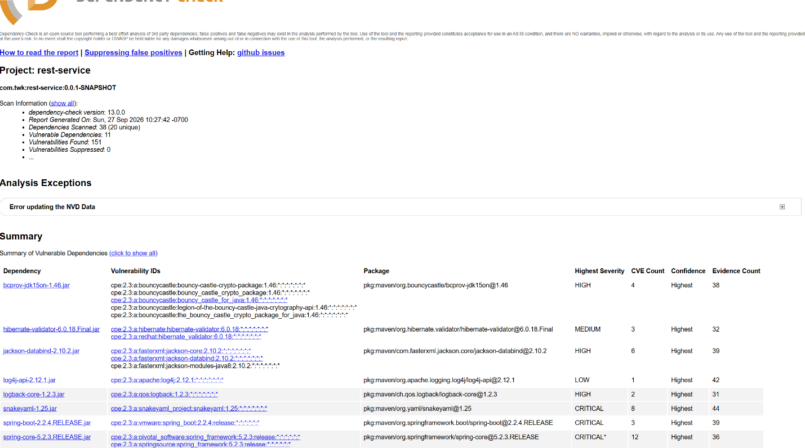

bcprov-jdk15on-1.46.jar
- Bouncy Castle CPE for version 1.46
- The application uses an old version of the Bouncy Castle cryptography library. To fix this, upgrade to a current version of Bouncy Castle and retest the cryptographic features.
hibernate-validator-6.0.18.Final.jar
- Hibernate Validator CPE for 6.0.18
- This dependency version has security vulnerabilities. To fix this, upgrade Hibernate Validator to a newer, supported/patched version.
jackson-databind-2.10.2.jar
- Jackson Core, Jackson Databind, and Jackson Modules Java 8 CPEs
- Jackson Databind has identified security problems that can occur when handling application data. To fix these issues, upgrade Jackson Databind and other related Jackson components to the latest patched versions.
log4j-api-2.12.1.jar
- Apache Log4j CPE for 2.12.1
- The application contains an outdated Log4j component with a known vulnerability. The solution is to upgrade the logging dependency to a supported version.
logback-core-1.2.3.jar
- QOS Logback CPE for 1.2.3
- Logback dependency has known security vulnerabilities. To fix this, upgrade Logback to a supported and patched version.
snakeyaml-1.25.jar
- SnakeYAML CPE for 1.25
- The application uses an outdated YAML library with known security vulnerabilities. To fix this, upgrade SnakeYAML and avoid processing untrusted YAML input unsafely.
spring-boot-2.2.4.RELEASE.jar
- VMware Spring Boot CPE for 2.2.4
- The Spring Boot release has multiple known vulnerabilities. To fix this, upgrade Spring Boot to a supported release.
spring-core-5.2.3.RELEASE.jar
- Spring Framework CPE for 5.2.3
- This version of the Spring Framework has several known security vulnerabilities. To fix this, upgrade to supported versions of Spring Boot and Spring Framework instead of maintaining the outdated version of Spring Core.
spring-web-5.2.3.RELEASE.jar
- Spring Framework CPE for 5.2.3
- This version of Spring Web has multiple vulnerabilities. To fix these problems, upgrade to the latest version of Spring Boot or Spring Framework, then retest the web application.
tomcat-embed-core-9.0.30.jar
- Apache Tomcat CPE for 9.0.30
- The embedded Tomcat version has many known vulnerabilities. To fix this, upgrade Tomcat. It’s best to do this with a supported Spring Boot version that manages compatible Tomcat dependency.
tomcat-embed-websocket-9.0.30.jar
- Apache Tomcat CPE for 9.0.30
- The Tomcat WebSocket component has several security vulnerabilities. To fix this, upgrade to a supported, patched version of Tomcat.

5. Mitigation Plan
Interpret the results from the manual review and static testing report. Then identify the steps to mitigate the identified security vulnerabilities for Artemis Financial’s software application.

Security risks at Artemis Financial were identified through manual review and testing, revealing outdated dependencies and vulnerabilities in application security. The Dependency-Check scan examined 38 dependencies, 20 of which were unique. It found 11 vulnerable dependencies with 151 reported vulnerabilities and no suppressed findings. The most critical vulnerabilities were SnakeYAML 1.25, Spring Boot 2.2.4, Spring Core 5.2.3, Spring Web 5.2.3, and Tomcat 9.0.30. Tomcat 9.0.30 had the most vulnerabilities, with 49 in the core component and 50 in the WebSocket component. The report also found vulnerabilities in Bouncy Castle, Jackson Databind, Hibernate Validator, Log4j, and Logback.
To mitigate these risks, the team should first upgrade all vulnerable dependencies to supported versions, prioritizing Spring Boot and its related Spring components, Tomcat, SnakeYAML, Jackson Databind, and Bouncy Castle. The application needs improvements to become more secure. Focus on better input validation, stronger authentication and authorization, improved API security, safer database access, and more effective error handling. Validate user input before processing, use parameterized statements for database queries, and implement authorization checks to prevent unauthorized resource access. Do not expose detailed error messages or stack traces to users; securely salt and hash passwords and use HTTPS/TLS for sensitive communications.
After remediation, the error associated with the NVD update as reported by Dependency-Check should be resolved. Then, the scan must be rerun using the most recent vulnerability data. Each remaining finding should be reviewed to determine whether it applies to the application's implementation, with verified false positives documented rather than automatically suppressed. The team can then perform regression and security testing to verify that dependency updates and code changes do not introduce new problems. They should also integrate regular dependency scanning, static analysis, code reviews, and secure coding practices into the software development lifecycle to mitigate future security risks.
Citations:
National Institute of Standards and Technology. (n.d.). Cryptography. https://www.nist.gov/cryptography
National Institute of Standards and Technology. (2022). Software security in supply chains: Open source software controls. https://www.nist.gov/itl/executive-order-14028-improving-nations-cybersecurity/software-supply-chain-security-guidance-22
OWASP Foundation. (2023). OWASP API Security Top 10. https://api-security.owasp.org/editions/2023/en/0x00-header/

